Polygonal Face

Definition
# Source: AI Source: Provided by: [Data Path: Persons Table -> ID Column: 1, Name_En Column: Motasem Essam] -> From: [ChatGPT] on [7/25/2026]
A polygonal face is a flat, two-dimensional region on the boundary of a three-dimensional solid that is shaped like a polygon. A polygon has straight sides joined end to end to form a closed boundary.
Polygonal faces are characteristic of polyhedra, such as cubes, cuboids, prisms, and pyramids.
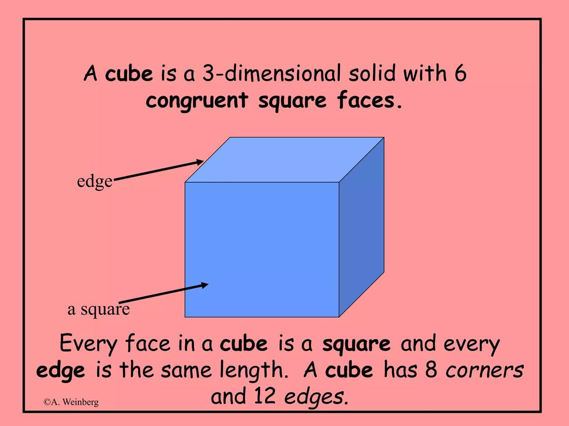
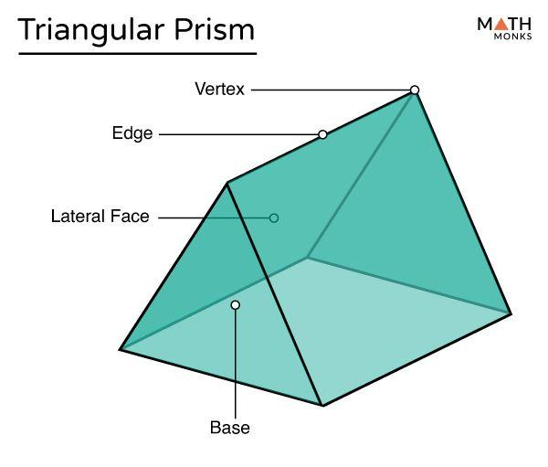
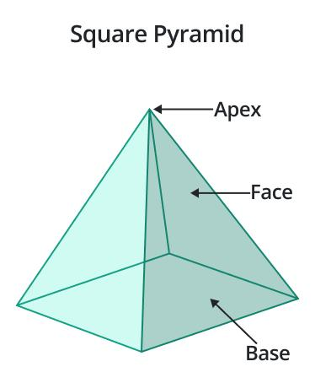

Simple Definition
# Source: AI Source: Provided by: [Data Path: Persons Table -> ID Column: 1, Name_En Column: Motasem Essam] -> From: [ChatGPT] on [7/25/2026]
A polygonal face is a flat polygon that forms part of the surface of a solid.
Examples:
- A square face on a cube.
- A rectangular face on a cuboid.
- A triangular face on a triangular prism.
- A pentagonal face on a pentagonal prism.

Classification Tree
# Source: AI Source: Provided by: [Data Path: Persons Table -> ID Column: 1, Name_En Column: Motasem Essam] -> From: [ChatGPT] on [7/25/2026]
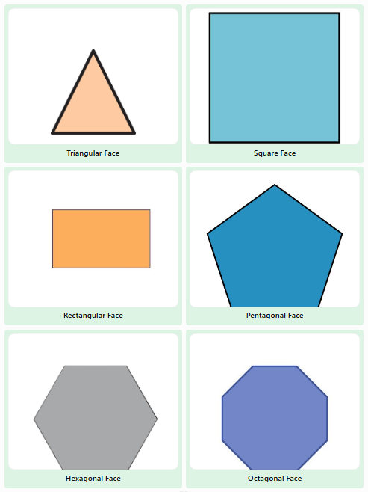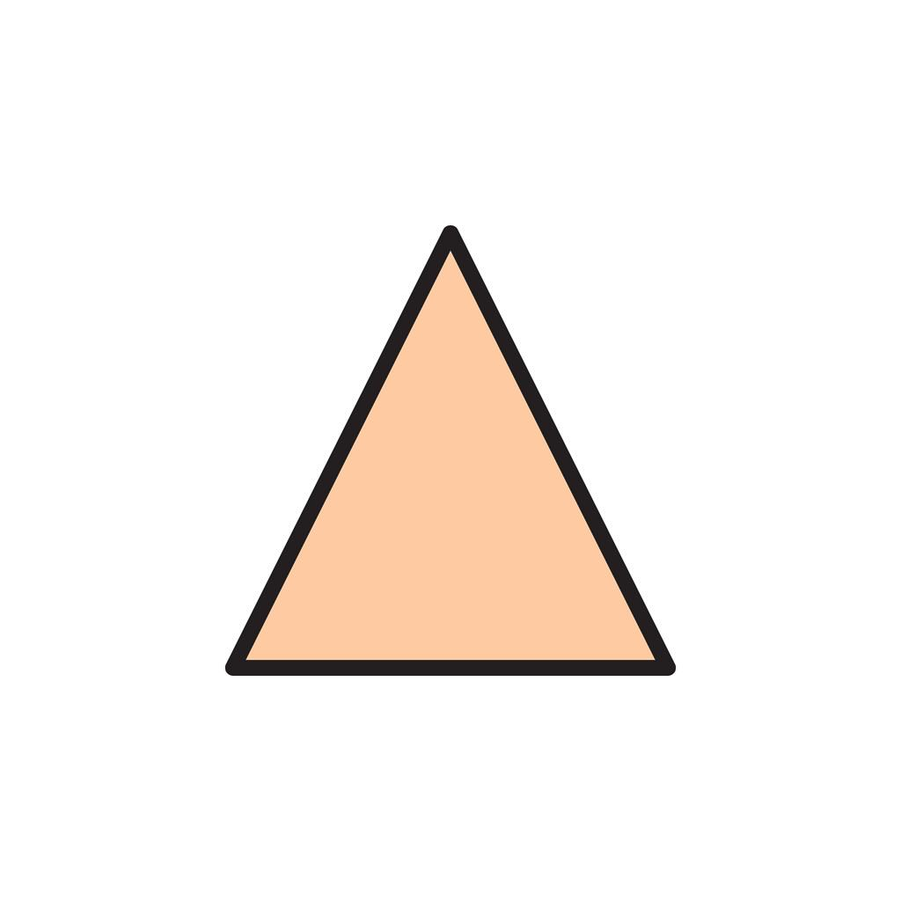
Triangular Face
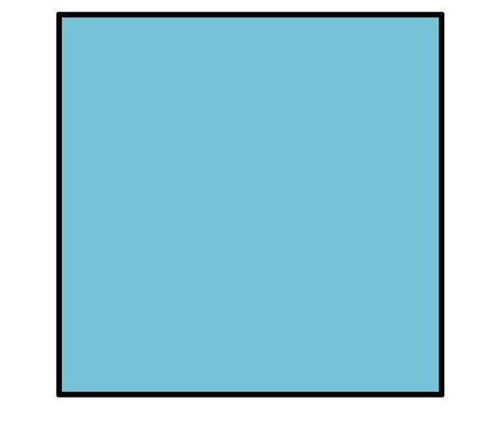
Square Face
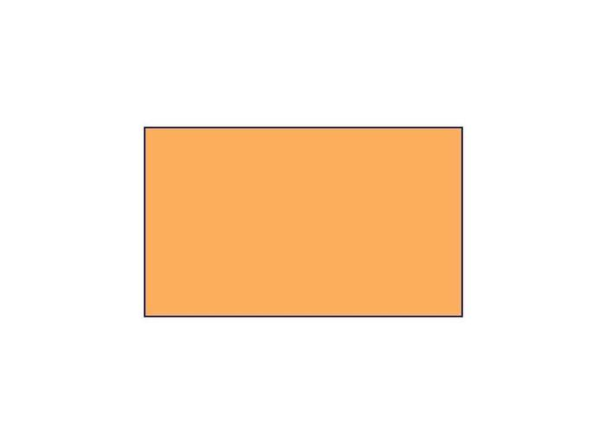
Rectangular Face
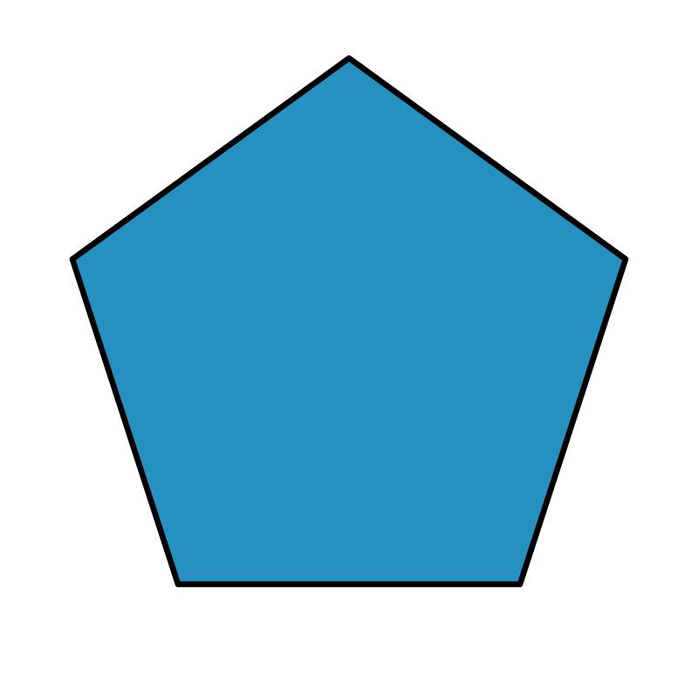
Pentagonal Face
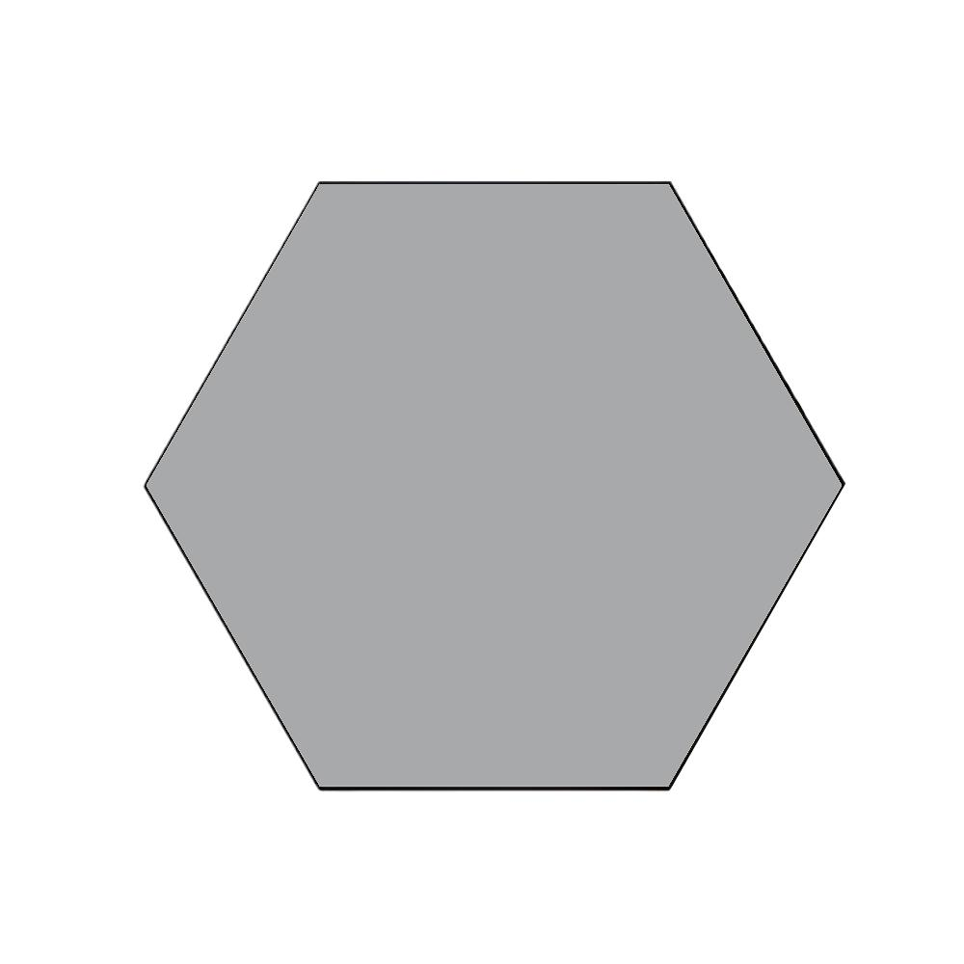
Hexagonal Face
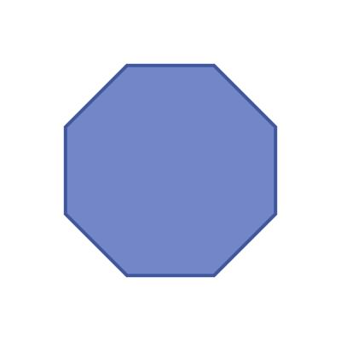
Octagonal Face
These types are classified by the shape of the polygon forming the face. A polygonal face can also be regular or irregular, depending on its side lengths and angles.

Key Characteristics
# Source: AI Source: Provided by: [Data Path: Persons Table -> ID Column: 1, Name_En Column: Motasem Essam] -> From: [ChatGPT] on [7/25/2026]
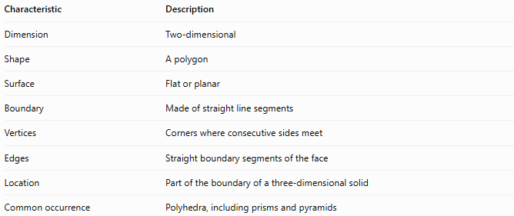
Characteristic | Description
Dimension | Two-dimensional
Shape | A polygon
Surface | Flat or planar
Boundary | Made of straight line segments
Vertices | Corners where consecutive sides meet
Edges | Straight boundary segments of the face
Location | Part of the boundary of a three-dimensional solid
Common occurrence | Polyhedra, including prisms and pyramids
A face is two-dimensional even though it belongs to a three-dimensional object.

Geometric Representation
# Source: AI Source: Provided by: [Data Path: Persons Table -> ID Column: 1, Name_En Column: Motasem Essam] -> From: [ChatGPT] on [7/25/2026]
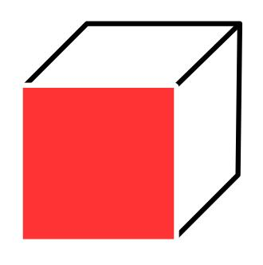
In a cube, every face is a square. Each square face has:
- 4 straight sides.
- 4 vertices.
- 4 boundary edges.
A cube has 6 polygonal faces, and all six are squares.
Other solids have different polygonal faces. For example, a triangular prism has two triangular faces and three rectangular faces.

Types of Polygonal Faces by Number of Sides
# Source: AI Source: Provided by: [Data Path: Persons Table -> ID Column: 1, Name_En Column: Motasem Essam] -> From: [ChatGPT] on [7/25/2026]
The polygon's number of sides determines the basic type of polygonal face.

Triangular face
# Source: AI Source: Provided by: [Data Path: Persons Table -> ID Column: 1, Name_En Column: Motasem Essam] -> From: [ChatGPT] on [7/25/2026]
3 sides and 3 vertices
Example: each lateral face of a triangular pyramid.
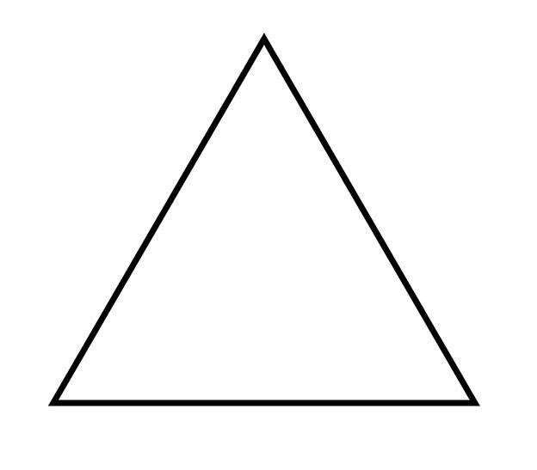

Quadrilateral face
# Source: AI Source: Provided by: [Data Path: Persons Table -> ID Column: 1, Name_En Column: Motasem Essam] -> From: [ChatGPT] on [7/25/2026]
4 sides and 4 vertices
Example: a square face of a cube or a rectangular face of a cuboid.
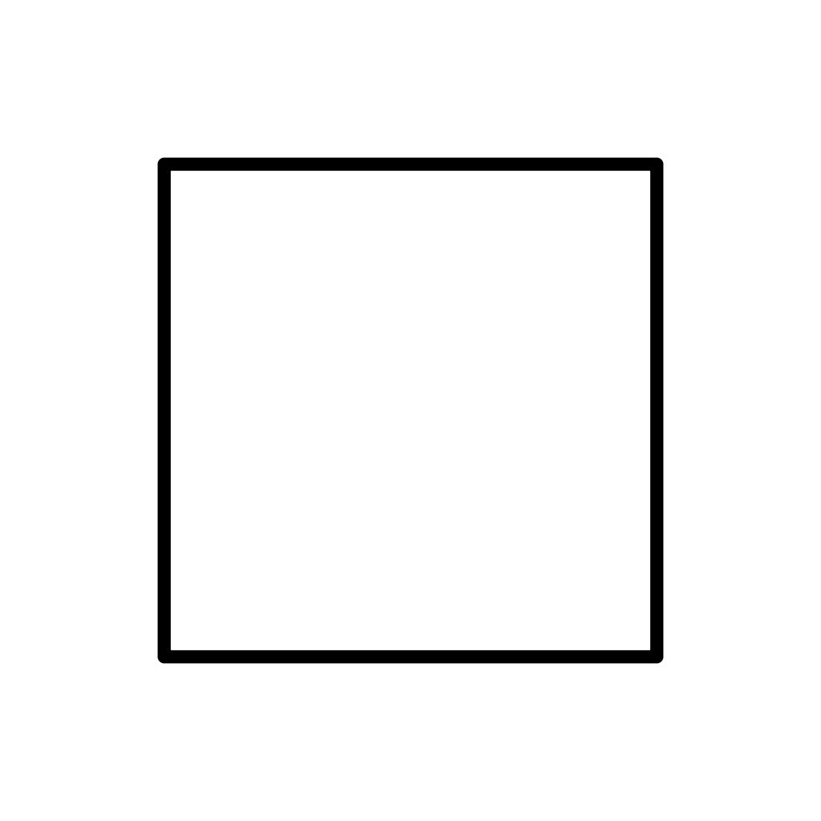

Pentagonal face
# Source: AI Source: Provided by: [Data Path: Persons Table -> ID Column: 1, Name_En Column: Motasem Essam] -> From: [ChatGPT] on [7/25/2026]
5 sides and 5 vertices
Example: a pentagonal base of a pentagonal prism.
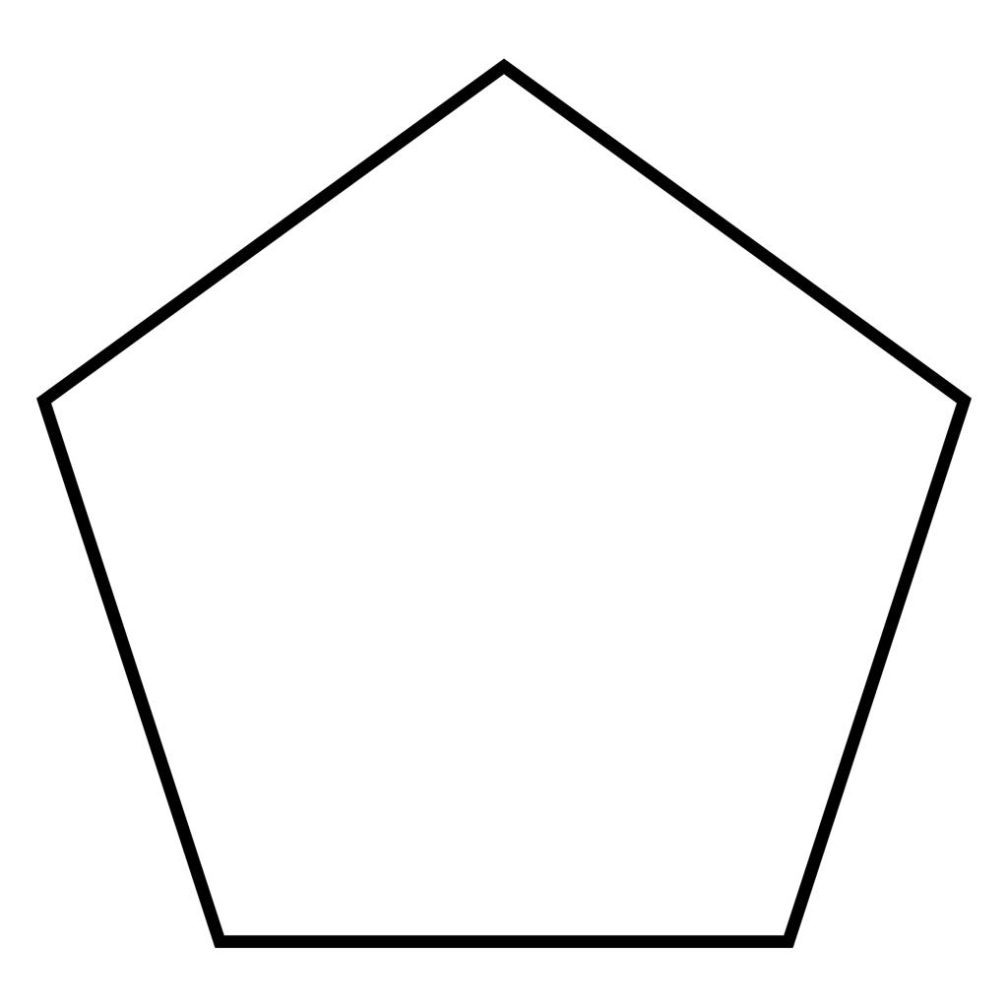

Hexagonal face
# Source: AI Source: Provided by: [Data Path: Persons Table -> ID Column: 1, Name_En Column: Motasem Essam] -> From: [ChatGPT] on [7/25/2026]
6 sides and 6 vertices
Example: a hexagonal base of a hexagonal prism.
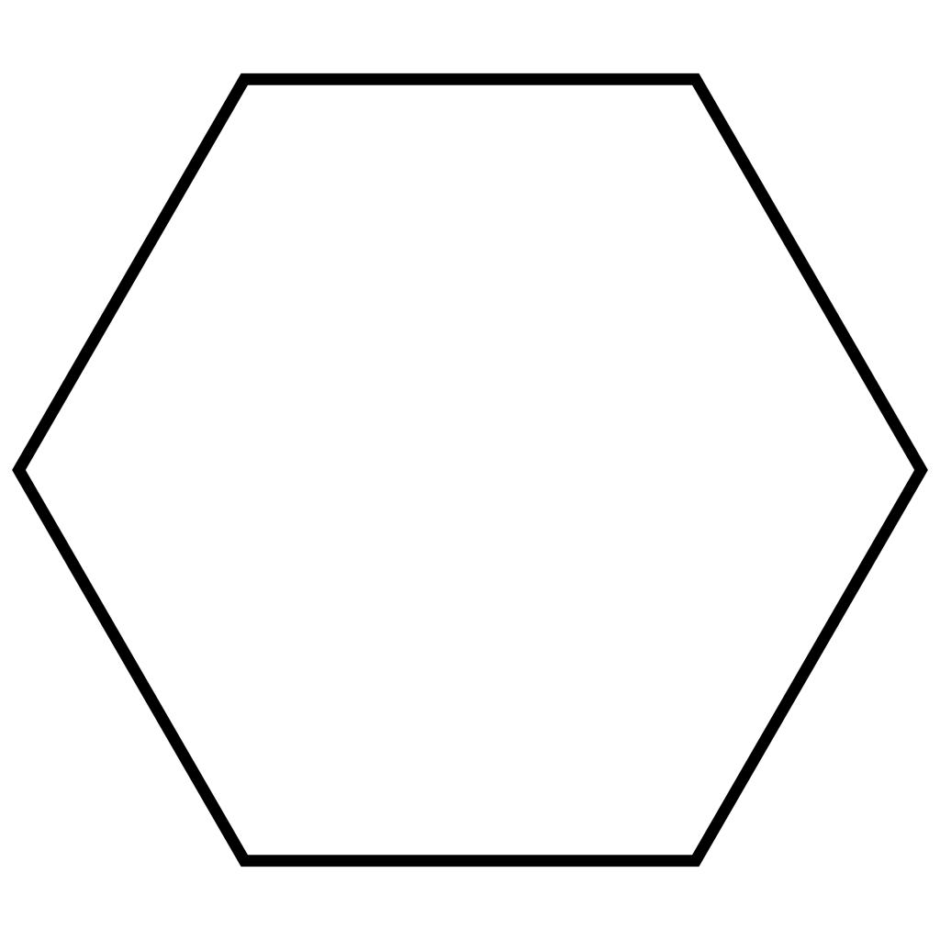

Octagonal face
# Source: AI Source: Provided by: [Data Path: Persons Table -> ID Column: 1, Name_En Column: Motasem Essam] -> From: [ChatGPT] on [7/25/2026]
8 sides and 8 vertices
Example: an octagonal base of an octagonal prism.
A polygonal face may have any valid polygonal shape, including polygons with more than eight sides.
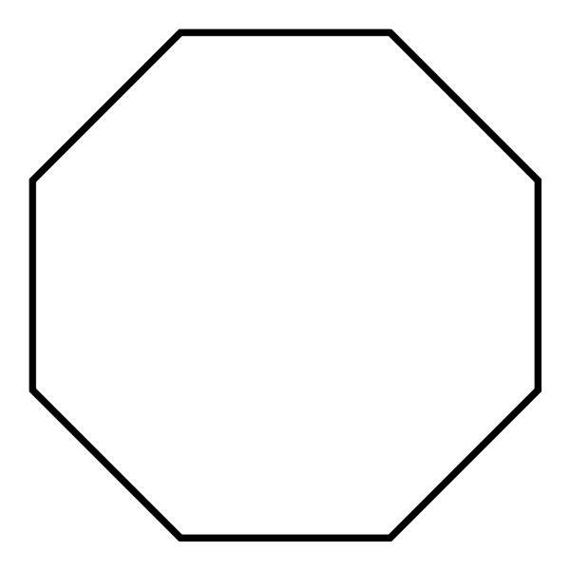

Mathematical Representation

A. Number of sides and vertices
# Source: AI Source: Provided by: [Data Path: Persons Table -> ID Column: 1, Name_En Column: Motasem Essam] -> From: [ChatGPT] on [7/25/2026]
For a polygonal face with $n$ sides:
$$\text{Number of sides}=n$$
$$\text{Number of vertices}=n$$
For example, a hexagonal face has $n=6$, so it has six sides and six vertices.

B. Interior angle sum
# Source: AI Source: Provided by: [Data Path: Persons Table -> ID Column: 1, Name_En Column: Motasem Essam] -> From: [ChatGPT] on [7/25/2026]
For a simple polygon with $n$ sides, the sum of its interior angles is
$$S=\left(n-2\right)×{180}^{∘}$$
For a pentagonal face:
$$S=\left(5-2\right)×{180}^{∘}={540}^{∘}$$
For a regular polygonal face, each interior angle measures
$$α=\frac{\left(n-2\right)×{180}^{∘}}{n}$$
This formula assumes the face is a regular polygon.

C. Area of a polygonal face
# Source: AI Source: Provided by: [Data Path: Persons Table -> ID Column: 1, Name_En Column: Motasem Essam] -> From: [ChatGPT] on [7/25/2026]
The area depends on the polygon's shape and dimensions.
Face shape | Area formula
Triangle | $$A=\frac{1}{2}bh$$
Rectangle | $$A=lw$$
Square | $$A=s^{2}$$
Regular polygon | $$A=\frac{1}{2}ap$$
Here, $b$ is a triangle's base, $h$ its perpendicular height, $l$ and $w$ are rectangle dimensions, $s$ is the square's side length, $a$ is a regular polygon's apothem, and $p$ is its perimeter.

Worked Examples
# Source: AI Source: Provided by: [Data Path: Persons Table -> ID Column: 1, Name_En Column: Motasem Essam] -> From: [ChatGPT] on [7/25/2026]
Example 1: Polygonal faces of a cube
A cube has six square faces.
Each face has four sides and four vertices.
- Number of faces: $F=6$
- Number of sides per face: $4$
- Shape of each face: square
If each edge is $3\text{ cm}$, the area of one face is
$$A=3^{2}=9{\text{ cm}}^{2}$$
The total surface area is
$$SA=6×9=54{\text{ cm}}^{2}$$
Example 2: Polygonal faces of a triangular prism
A triangular prism has five faces:
- Two triangular faces.
- Three rectangular faces.
Therefore, all five faces are polygonal.
If the triangular base has area $12{\text{ cm}}^{2}$, and each rectangular face has areas $20{\text{ cm}}^{2}$, $24{\text{ cm}}^{2}$, and $28{\text{ cm}}^{2}$, then the total surface area is
$$SA=2\left(12\right)+20+24+28$$
$$SA=96{\text{ cm}}^{2}$$
Example 3: Polygonal faces of a square pyramid
A square pyramid has five polygonal faces:
- One square base.
- Four triangular lateral faces.
If the square base has side length $4\backslash text\{ cm\}$, its area is
$$A=4^{2}=16{\text{ cm}}^{2}$$
The four triangular faces are also polygonal faces, but their areas depend on the pyramid's slant height.

Comparison with Related Concepts
# Source: AI Source: Provided by: [Data Path: Persons Table -> ID Column: 1, Name_En Column: Motasem Essam] -> From: [ChatGPT] on [7/25/2026]
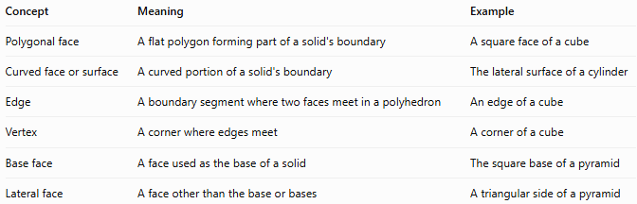
Concept | Meaning | Example
Polygonal face | A flat polygon forming part of a solid's boundary | A square face of a cube
Curved face or surface | A curved portion of a solid's boundary | The lateral surface of a cylinder
Edge | A boundary segment where two faces meet in a polyhedron | An edge of a cube
Vertex | A corner where edges meet | A corner of a cube
Base face | A face used as the base of a solid | The square base of a pyramid
Lateral face | A face other than the base or bases | A triangular side of a pyramid
Important distinction: In standard elementary solid geometry, a polygonal face is flat and bounded by straight segments. A cylinder's curved lateral surface is not a polygonal face.

Regular and Irregular Polygonal Faces
# Source: AI Source: Provided by: [Data Path: Persons Table -> ID Column: 1, Name_En Column: Motasem Essam] -> From: [ChatGPT] on [7/25/2026]
Polygonal faces can also be classified according to whether their polygons are regular or irregular.

Regular polygonal face
# Source: AI Source: Provided by: [Data Path: Persons Table -> ID Column: 1, Name_En Column: Motasem Essam] -> From: [ChatGPT] on [7/25/2026]
All sides have equal lengths, and all interior angles are equal.
Example: a regular hexagonal face.
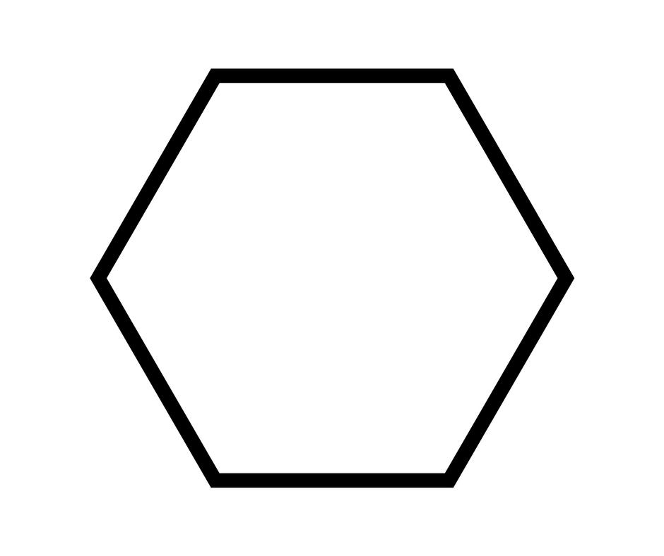

Irregular polygonal face
# Source: AI Source: Provided by: [Data Path: Persons Table -> ID Column: 1, Name_En Column: Motasem Essam] -> From: [ChatGPT] on [7/25/2026]
Its sides and angles are not all equal.
Example: an irregular pentagonal face.
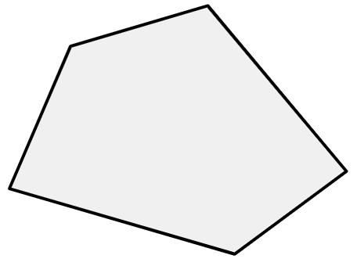
A polygonal face does not need to be regular. For example, the rectangular faces of a non-cubic cuboid are polygonal faces even when their dimensions differ.

Applications of Polygonal Faces
# Source: AI Source: Provided by: [Data Path: Persons Table -> ID Column: 1, Name_En Column: Motasem Essam] -> From: [ChatGPT] on [7/25/2026]
Polygonal faces are important in many areas of mathematics and practical design.
- Architecture: Identifying the flat faces of buildings and structural components.
- Engineering: Calculating surface areas and designing polyhedral parts.
- Computer graphics: Representing three-dimensional objects using polygon meshes.
- Packaging: Designing boxes, cartons, and polygonal containers.
- Mathematics: Studying polyhedra, surface area, edges, vertices, and geometric relationships.

Key Points
# Source: AI Source: Provided by: [Data Path: Persons Table -> ID Column: 1, Name_En Column: Motasem Essam] -> From: [ChatGPT] on [7/25/2026]
- A polygonal face is a flat, two-dimensional polygon on a solid's boundary.
- It has straight sides, vertices, and a well-defined polygonal area.
- Its shape may be triangular, quadrilateral, pentagonal, hexagonal, or another polygon.
- It may be regular or irregular.
- Polyhedra have polygonal faces; spheres and cylinders have curved surface portions that are not polygonal faces.
- The total surface area of a polyhedron is the sum of the areas of its faces.

Conclusion
# Source: AI Source: Provided by: [Data Path: Persons Table -> ID Column: 1, Name_En Column: Motasem Essam] -> From: [ChatGPT] on [7/25/2026]
A polygonal face in solid geometry is a flat polygon that forms part of the surface of a three-dimensional solid. Recognizing polygonal faces helps us classify solids, count their faces, identify their edges and vertices, and calculate their surface areas.

